Internet Addiction Final Website

**Project scope**

5 Main pages

(Johnny) Main Page – general information

(Kyle) Form Page – submit email request – contact information

(Amel) Content Page – Tips and tricks to avoid internet addictions

(Tristin) Content Page – Instructional Video

(Rhett) Content Page – History and causes

Supplemental pages

Submit page – Confirmation that form was submitted.

Email Page – HTML page that is emailed to user.

Header/Footer

(Rhett) Footer - PHP

Copyright information

Last Updated

(Kyle) Header - PHP

Website Title

Navigation

Site Wide favicon

Site Wide accessibility

Styling

CSS – As a team after pages are setup

Determine styling for header, footer, body

Let the rest of the team know what our classes and id’s should look like

**Project features**

Web Form: Need help with your internet addition form? Sends confirmation mail to client. Uses JavaScript on the front end to verify data using regular expressions.

Captcha V2: On the front-end JavaScript checks that Captcha has been checked. On the back-end PHP double checks (in case JavaScript is disabled) before sending email.

RESTful API: Used to get video description data from YouTube. Requires registration of domain and SSL certification.

Dynamic Content: Images, headers, text, and other web elements are dynamically sized using @media tags within our CSS document.

**Timeline**

March 6th: All members meet to plan collaboration techniques using Code Anywhere. We also planned how and where we were going to host our website. We decided to use a personal web server at address [www.qwep.com](http://www.qwep.com).

April 4th: All members short of Amel meet to discuss format of website, assign tasks, make basic style decision, and create timeline.

April 5th: Filled in Amel about previous meeting topics

April 11th: Codeanywhere does not allow you to view PHP pages which is inconvenient so we decided to use GitHub as a repository and collaboration software instead. The repository is kept at <https://github.com/KyleAure/CS344WebsiteProject>. We cleaned up all of the pages to have a similar format and just need to keep working on our assigned pages.

April 12th: Amel and Rhett were not able to make this meeting. Filled them in during Data Structures on Thursday and helped them set up their IED with git integration so that they can update the project as needed.

April 18th: All team members meet to wrap up final design decisions.

April 23rd: Meet to finish final report.

April 24th: Project finished and presentation day

**Test Plans**

We plan to test our website on both Mac and Windows operating systems with a variety of browsers; Chrome, Firefox, Internet Explorer, and Safari. Similarly, we will test our website on mobile platforms using similar browsers on Android and IOS devices.

In addition to hardware testing we plan to test our website for accessibility using [www.CynthiaSays.com](http://www.CynthiaSays.com). For syntax errors we plan to check out site using <http://validator.w3.org>

**Test Results**

While testing our website on different browsers we ran into issues where the browser styles were overriding some of our external styles. As a result we decided to create a Reset.CSS file to clear style settings between web browsers.

While testing our website on mobile devices our original plan to have dynamic font sizes resulted in fonts that were very small on mobile devices. As a result, we decided to use static font sizes on mobile devices using @media tags.

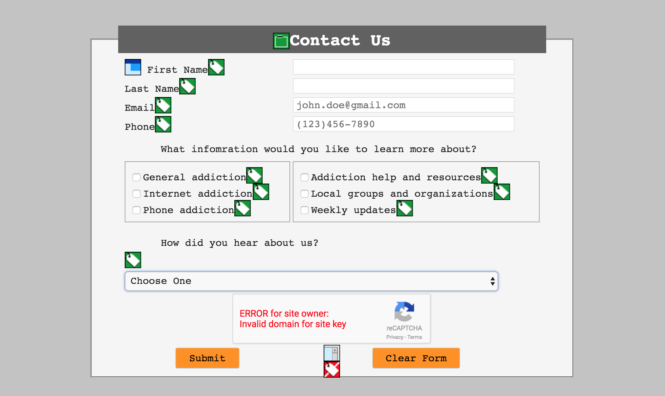 We attempted to use [www.CynthiaSays.com](http://www.CynthiaSays.com) to check our accessibility, but we got a timeout error every time we attempted this so instead we used a site called <http://wave.webaim.org/> which gave us very helpful information especially on the form page to make sure everything was accessible see screenshot to the right.

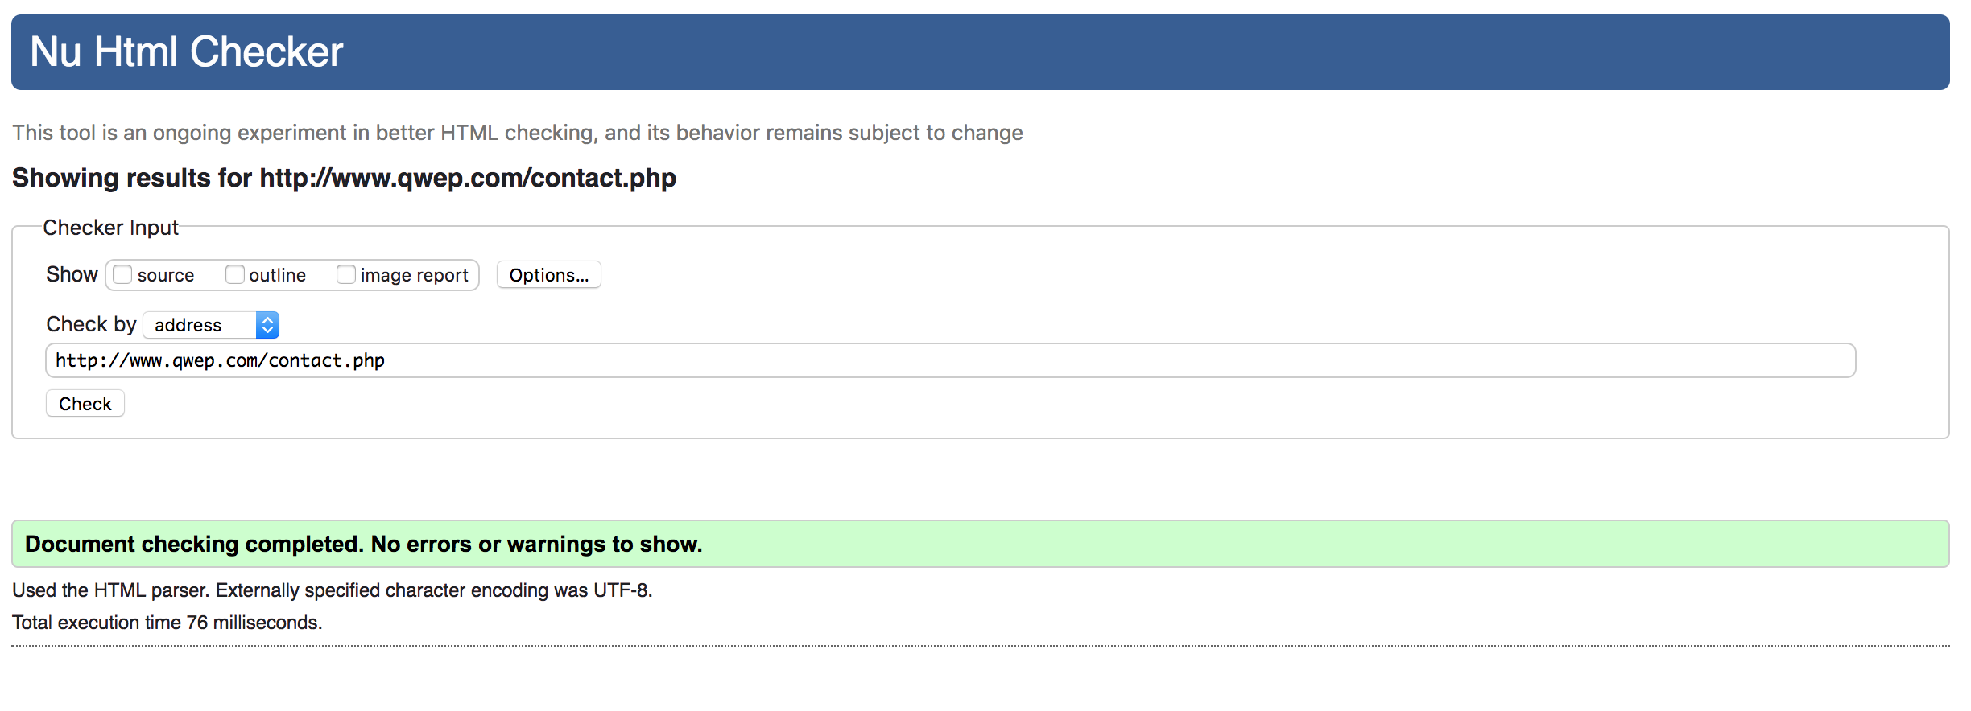 The result from [http:/ /validator.w3.org](http://validator.w3.org) also gave really good insights into the syntax of all of our websites. Even though no errors appeared in the browser inspector it still found unclosed tags and many other minor errors that we did not find on our own.

**Interesting / Unexpected**

While working on the same documents we ran into a couple instances where duplicate files that needed to be resolved. Additionally, there were times when users uploaded files to the web server but forgot to keep the project in GitHub updated. We used GitHub for our version control in the end. During these processes many team members learned how to use GitHub for the first time.

Styles between the pages started off separate and we needed to coordinate to create a consistent style between pages. This was hard at first when everyone was using their own class and id names for the same type of content. In the end, we created uniformed styling names and applied them site wide.

During form development we had to figure out a way to check if the form was completed both on the client side and server side. We decided to use a Captcha V2 to do the checking. This was pretty simple as we just had to register the domain with a google account. Then on the front-end use JavaScript to check that the captcha was clicked before submission, and double check on the backend with PHP, incase, a user has JavaScript turned off.

For the instructional videos page we decided to include the video descriptions as part of the page. To do this we could have just copied and pasted the description contact into the page. But instead we decided to use the YouTube RESTful API to grab the JSON formatted content, parse it to an array, and display it on the page.

Flowchart

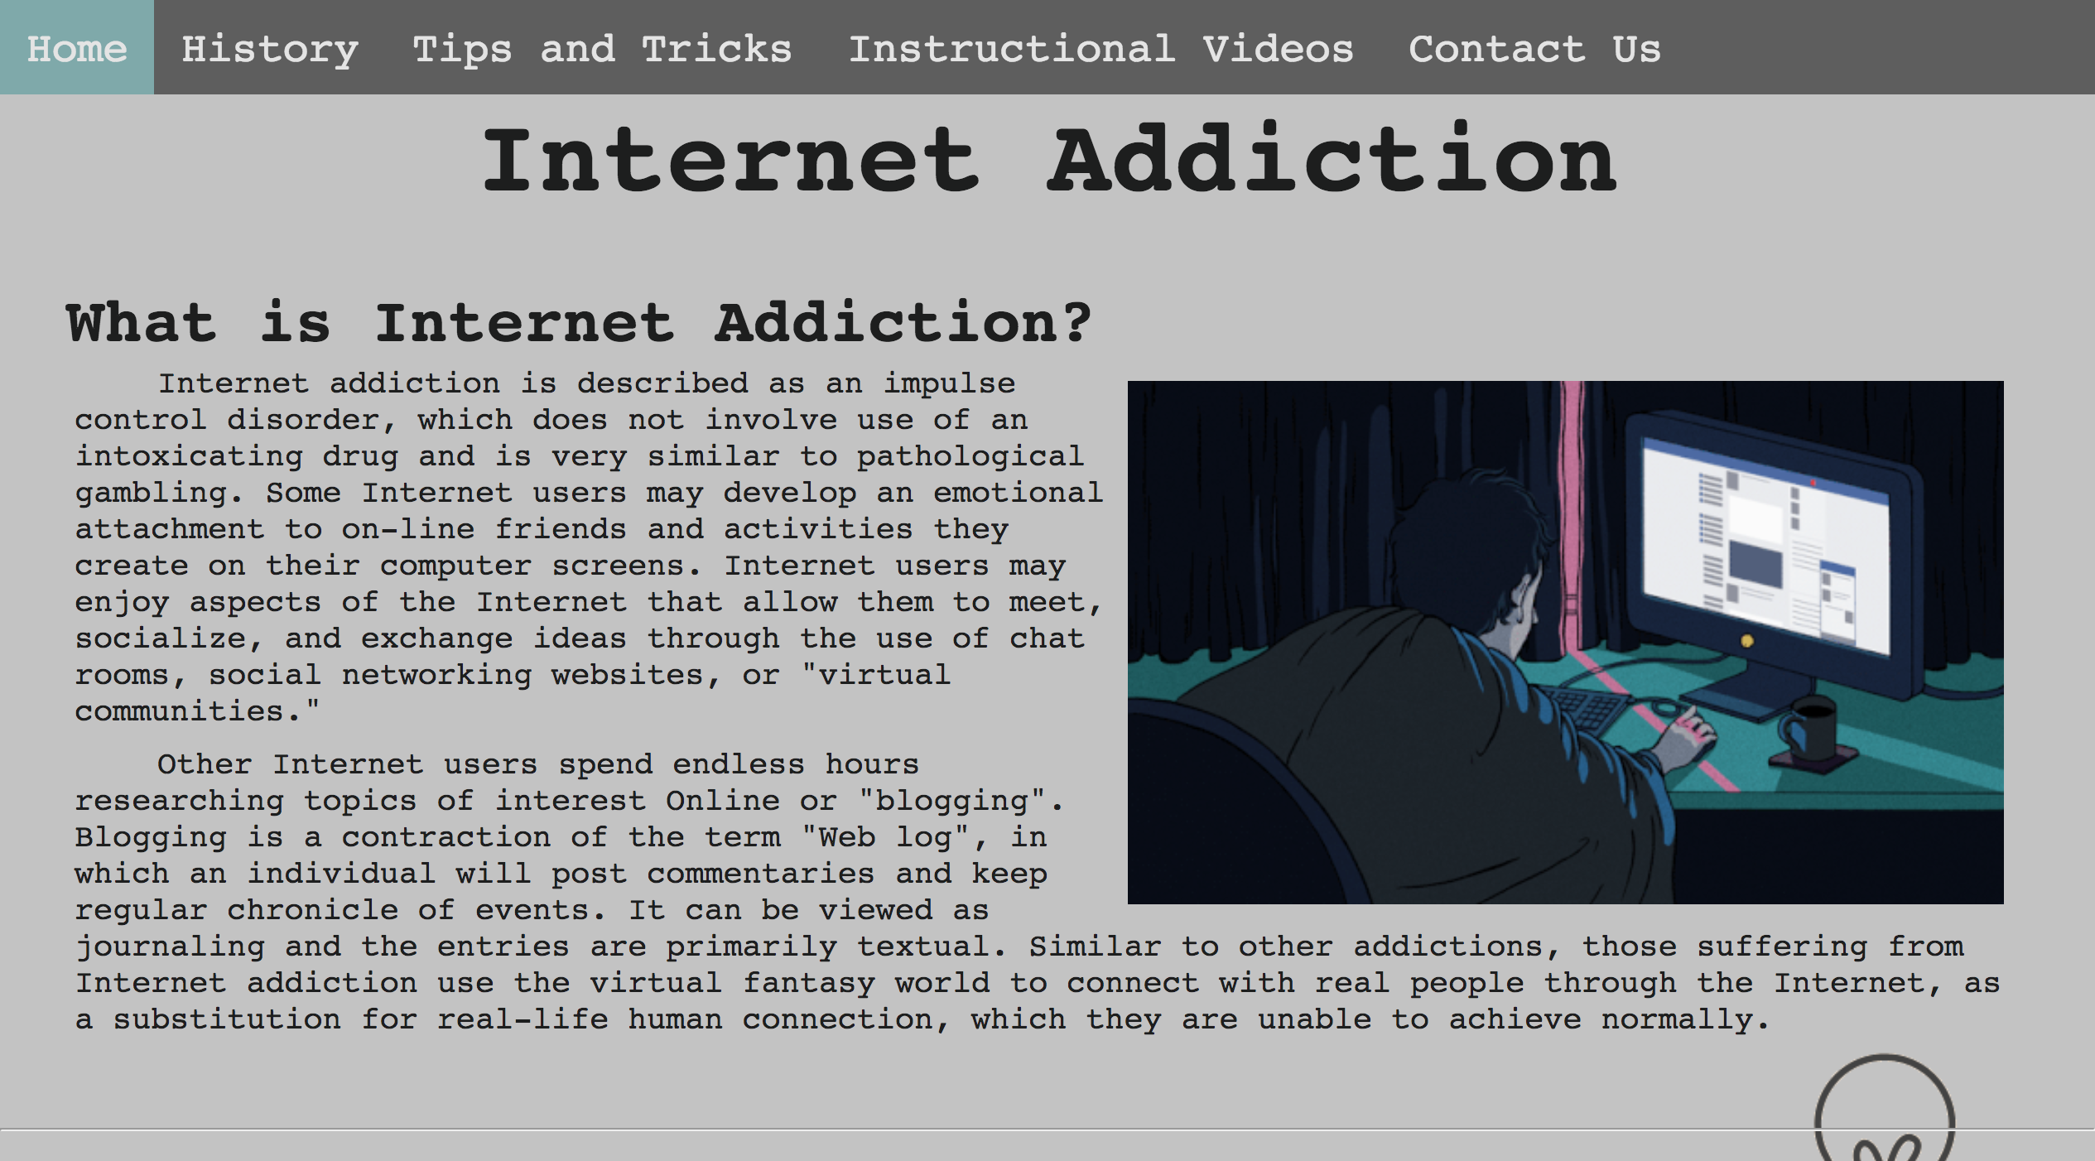

Start on home page at http://www.qwep.com

Navigate through the pages as you see fit.

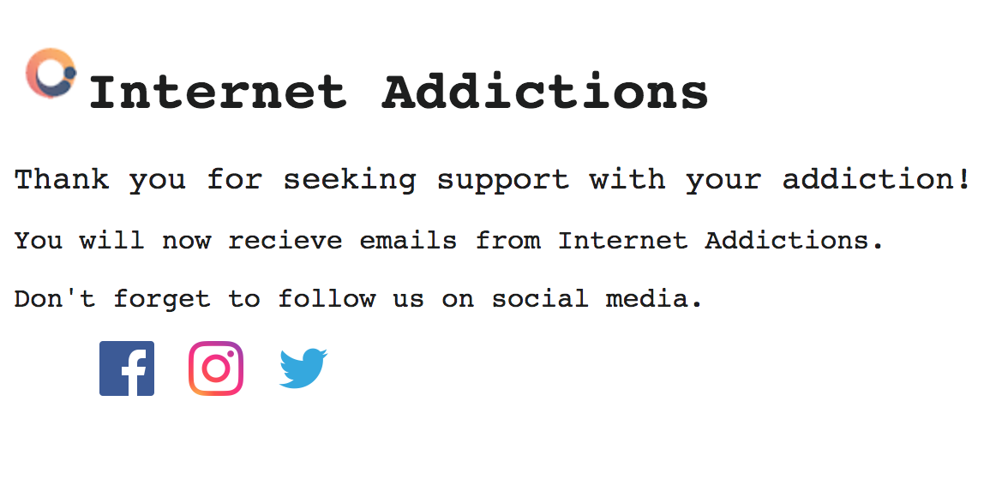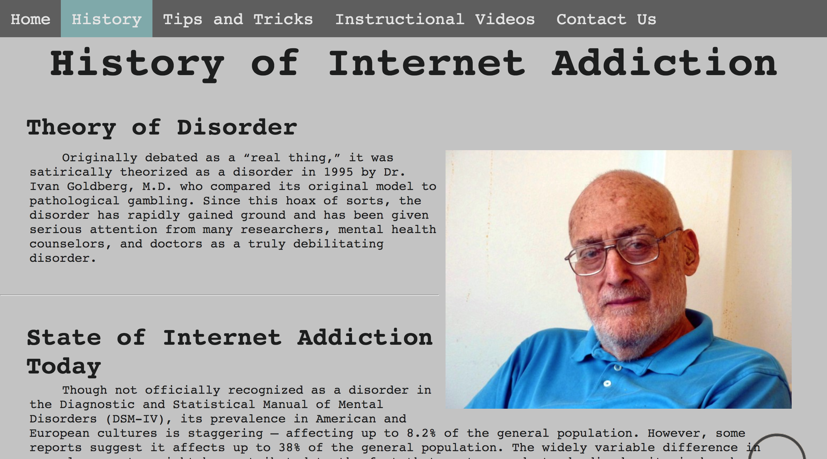

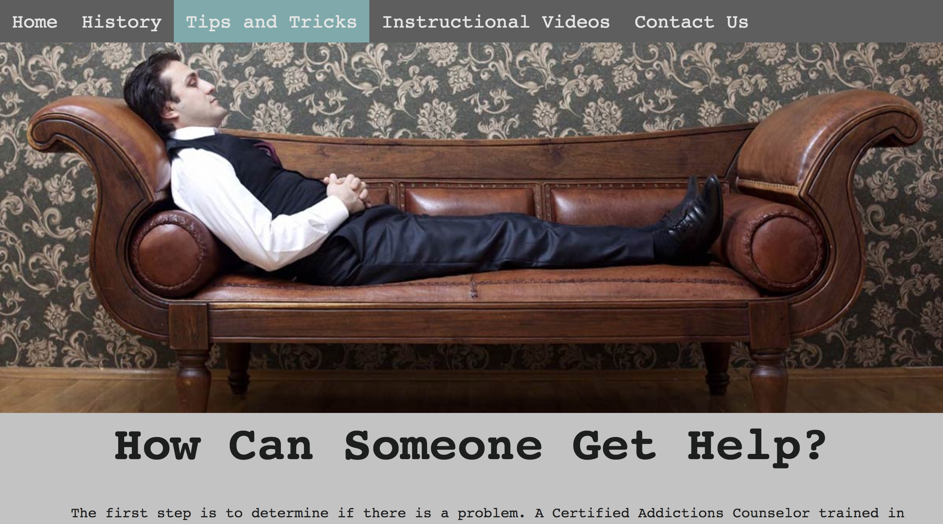

Email user receives from server

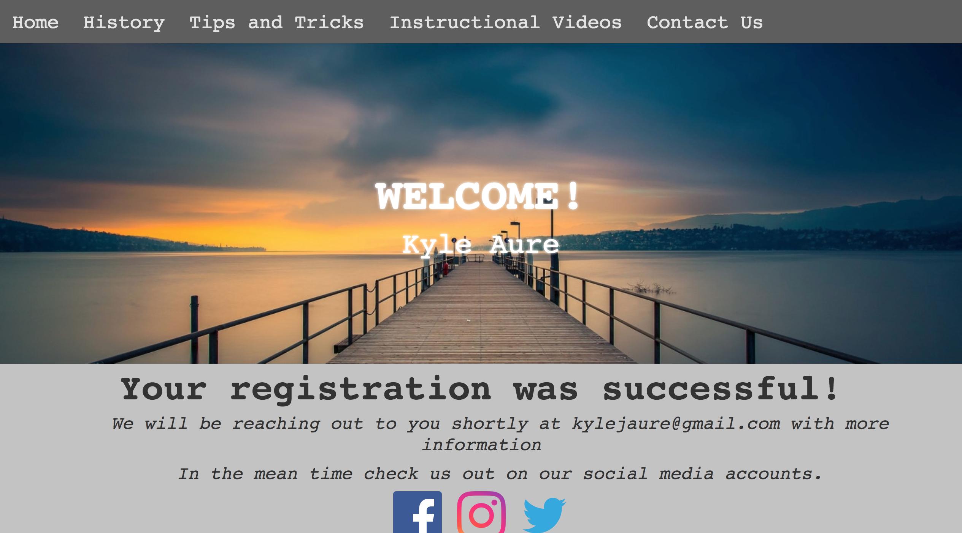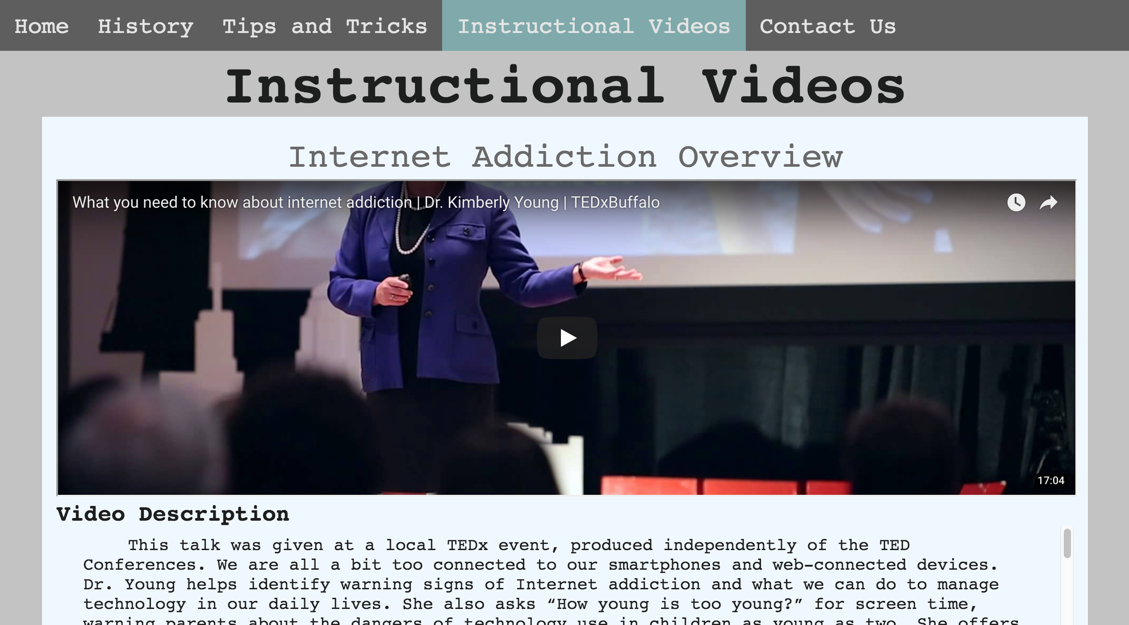

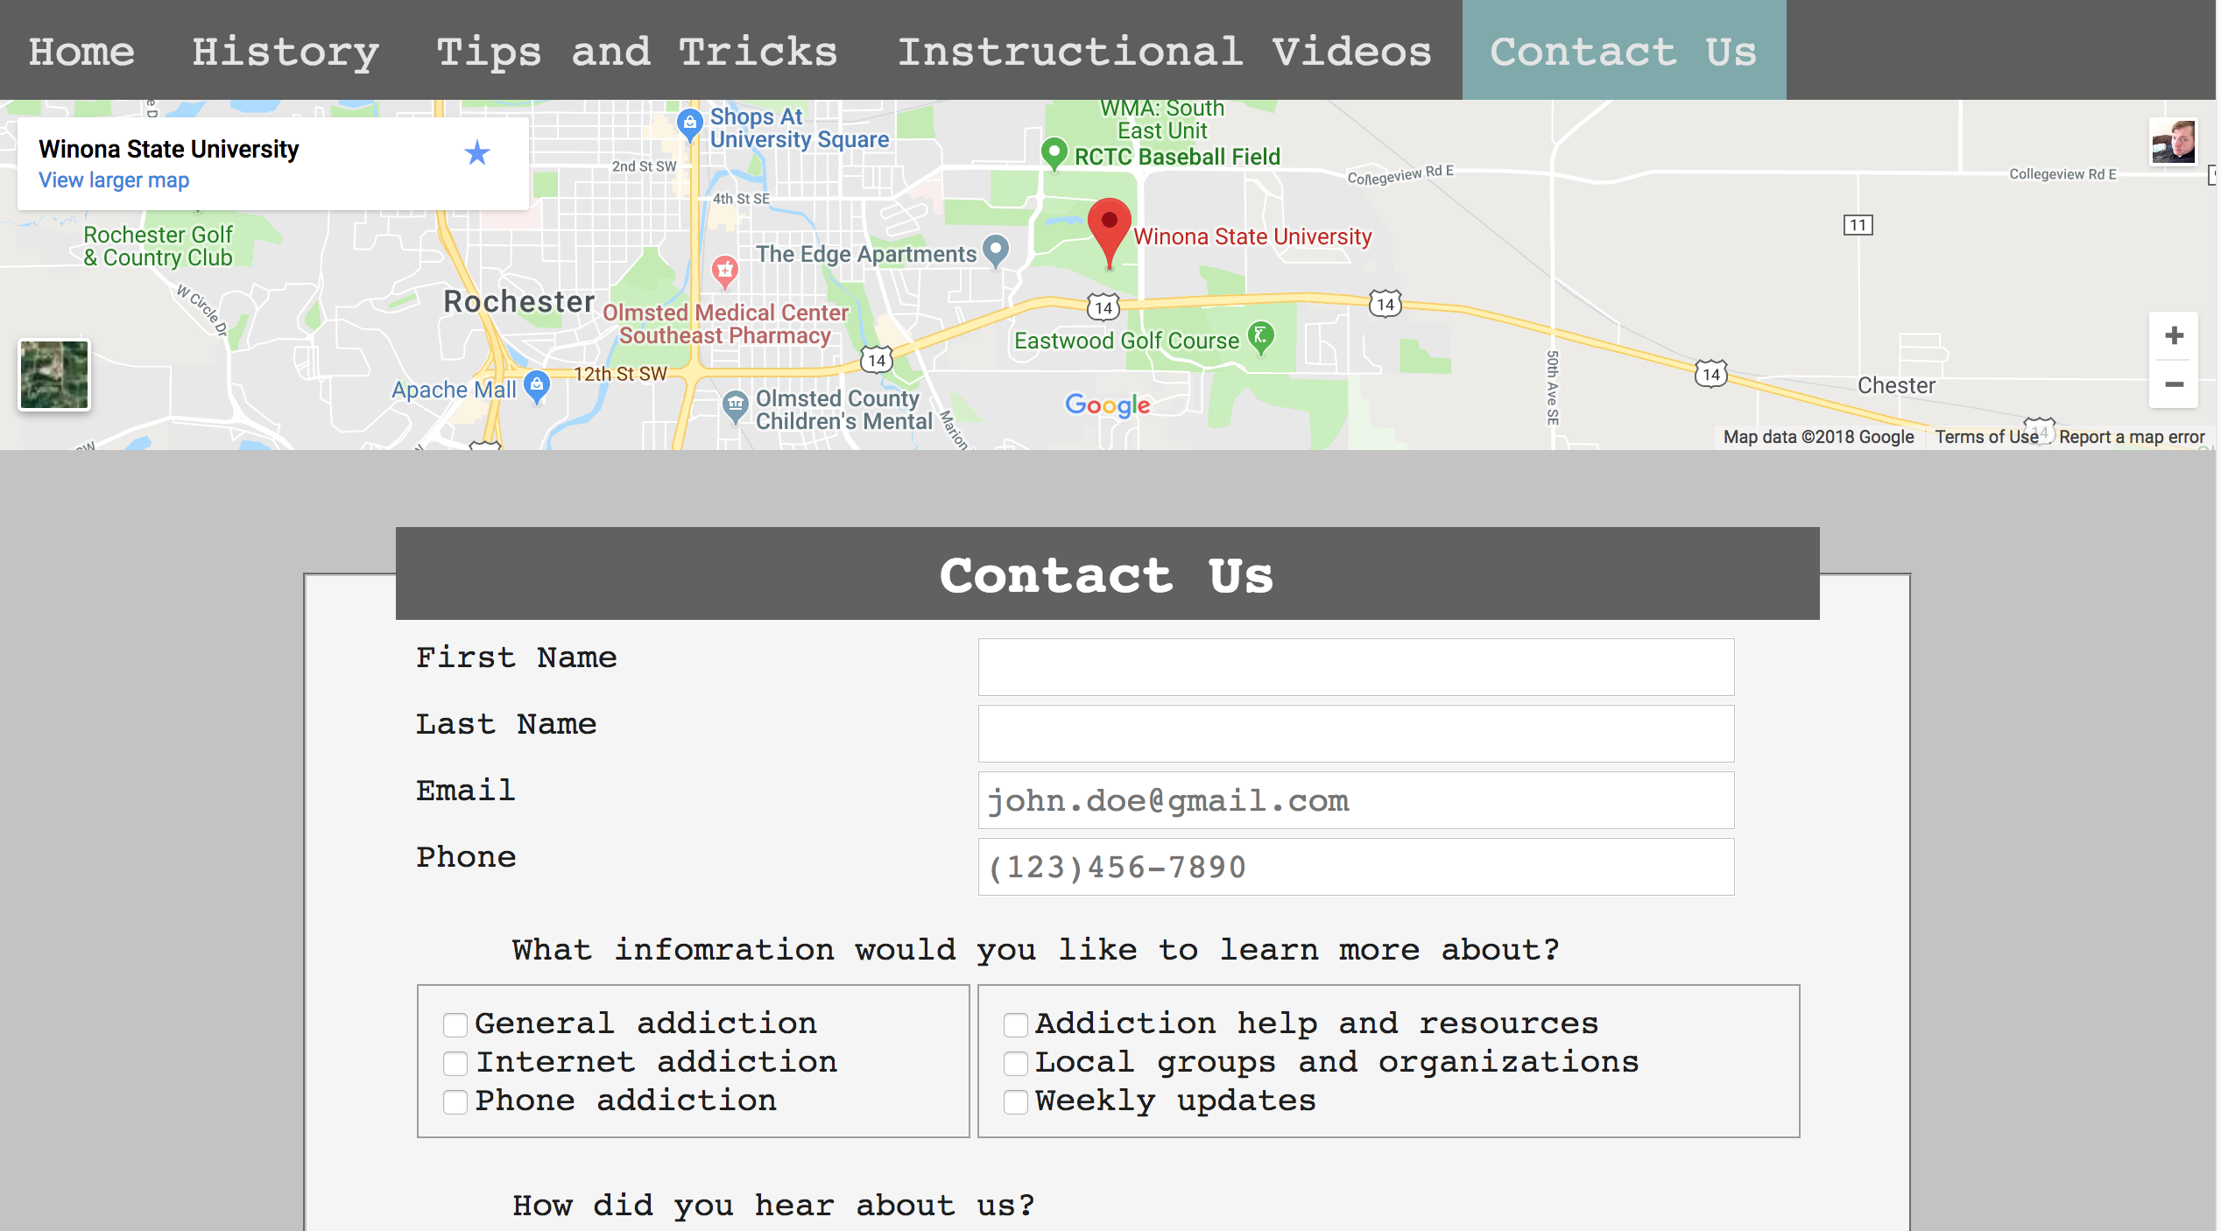

Submit page shown after filling out contact us form.